

E-Project-PUPPIES

**Batch -2109d**

**“_______________”**

**PREPARED BY:**

* **Musfirah Kashan**
* **Safa Kashan**

**THIS IS TO CERTIFY THAT**

* **Musfirah Kashan**
* **Safa Kashan**

**Have Successfully Designed & Developed:**

“Puppies Website”

***___ 15-jan-2022_________________________***

**Date of Submission**

**TABLE OF CONTENT**

*Acknowledgment 4*

*Introduction 5*

*Preface 6*

*Problem Statement 7*

*Scope of work 8*

*Architecture and design of the system 9*

*Task Sheet: 10*

*Checklist of validations 11*

*Submission checklist 12*

*System requirements 13*

*Links 14*

*Activity time 15*

*Activity#1 16*

*Activity#2 17*

*Get in touch 18*

**ACKNOWLEDGEMENT**

We are thankful to Almighty ALLAH that by his grace we have been successful. We have tried our best to consider all relevant important topics so that this project may become comprehensive.

This is our FIRST SEMESTER project. We have tried our best & struggled for a better outlook to come. This project has been developed in ‘VISUAL STUDIO CODE’. We find it easy to do coding in ‘VISUAL STUDIO CODE’.

We earnestly hope that this project will provide all this necessary information required for the user to fulfill their inspiration. However, suggestions for improvement of the project will be thankfully received & acknowledged.

THANK YOU.

**INTRODUCTION**

The Thirst for learning, upgrading technical skills, and applying the concepts in the real-life environment at a fast pace is what the industry demands from IT professionals Today. However busy work schedules, far-flung locations, unavailability of convenient time-slots pose as major barriers when it comes to applying the concepts into realism. And hence the need to look out for alternative means of implementation in the form of a laddered approach.

The above truly pose constraints especially for our students too! With their busy schedules, it is indeed difficult for our students to keep up with the genuine and constant need for an integrated application which can be seen live especially so in the field of IT education where technology can change on the spur of a moment. Well, technology does come to our rescue at such times.

Keeping the above in mind and in tune with our constant Endeavour to use Technology in our training model, we at APTECH have thought of revolutionizing the way our students learn and implement the concepts using tools themselves by providing a live and synchronous e-Project learning environment.

**PREFACE**

First of all, we would like to thank Almighty God, who gave us the mind to think and heart to feel creative. Creation depends on thinking.

Many people contributed to this project, and we would like to thank all of them. I guess we should start with our teachers Sir Mouwaiz, Miss Esha, and Sir Kousar faculty of APTECH GARDEN CENTER for their expert advice and support in creating this website.

Very special thanks to all our teachers who gave us valuable teaching and brilliant suggestion and always encourage us to do our best. Indeed, class fellows are very important and we would like to thank all of them for their kind appreciation, encouragement, and moral support.

We would also like to express our deepest gratitude to our parents whose well wishes enabled us to transform our dream into a reality. Finally, our sincere thanks to all faculties of APTECH for all their help in making this concept a reality.

**PROBLEM STATEMENT**

Standard Plan:

1. The Logic of the Website must be Explained. Proper Documentation should be maintained.
2. Complete Project Report along with Synopsis, Code, and Documentation should be prepared.

Note: Don’t forget to back up your data.

SCOPE OF WORK

Following is the requirement’s based on which Website must be developed:

1. A home page will display menu options Gallery, contact us, about us, etc.
2. When you will click on the gallery in the navbar you will find out various pics of puppies, food and babies, etc. When you, will click on the different button the one present on the top you will lead to the respective pages of the gallery.
3. Contact us page should contain some relevant information.

Architecture and design of the system

This website will have a client-server architecture.



SERVER

CLIENTS

Front End Technologies

(Html5,

CSS3,

jQuery,

Bootstrap)

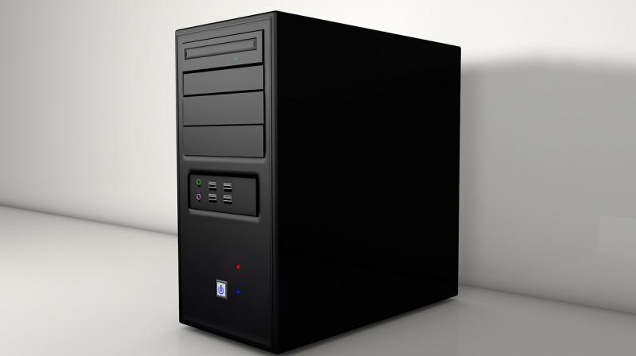



TASK SHEET

|  |  |  |  |  |
| --- | --- | --- | --- | --- |
| Sr.# | Task | DAYS SPEND | MEMBERS WORKING | STATUS |
| 1 | Data Collecting | 5 | Safa &Musfirah | Checkmark |
| 2 | WEBSITE planning | 2 | Safa & Musfirah | Checkmark |
| 3 | Designing | 3 | Safa & Musfirah | Checkmark |
| 4 | data  management | 2 | Safa & Musfirah | Checkmark |
| 5 | Coding | 15 | Safa & Musfirah | Checkmark |
| 6 | Documentation & Presentation | 3 | Safa & Musfirah | Checkmark |

CHECKLIST OF VALIDATIONS

|  |  |
| --- | --- |
| OPTION | VALIDATED |
| A) Do all text links lead to appropriate web pages? | Grinning face with no fill |
| B) Do all the images links lead to appropriate web pages? | Grinning face with no fill |
| C) Is the web page opening properly in all the tested web browsers? | Neutral face with no fill |
| D) Are the animations loading well? | Grinning face with no fill |
| E) Is the website responsive? | Grinning face with no fill |

Submission checklist

|  |  |  |  |
| --- | --- | --- | --- |
| SR.# | PARTICULARS | YES | NO |
| 1 | Are all users able to view images and links? | yes |  |
| 2 | Have all components of the website been integrated and do the load as expected? | yes |  |
| 3 | Is the website launching correctly in the browser? | yes |  |

USER GUIDE

SYSTEM REQUIREMENTS

|  |  |  |
| --- | --- | --- |
| NO. | ITEMS | DESCRIPTION |
| 1 | Operating system | Windows 8, 10, or higher |
| 2 | Software | Bootstrap 3.3 or higher libraries from getbootstrap.com, jQuery plugins, and Notepad++, or another HTML editor. |

Find links here

Bootstrap 3.3: <https://blog.getbootstrap.com/2016/07/25/bootstrap-3-3-7-released/>

Get bootstrap: <https://getbootstrap.com/>

jQuery plugins: <https://plugins.jquery.com/>

Notepad++: <https://notepad-plus-plus.org/downloads/>

Our website

Note:

Copy the above links to go their official webpage

***Shortcut key*** to go to their official page is

Ctrl+Click

Thank you!



Activity#1

1. Guess the breed.

A. known for being sociable and known companion dogs ___________

B. known for intelligence, eagerness to please, and willingness to work hard

_____________

C. Smartest dog _________

D. small size, big personality _______________

E. active and fun loving ________

Answers

A. Pug

B. Labrador Retriever

C. Poodle

D. Chihuahua

E. Beagle

Activity#2

2. find the dog’s name.

|  |  |  |  |  |  |  |  |  |  |  |  |
| --- | --- | --- | --- | --- | --- | --- | --- | --- | --- | --- | --- |
| B | U | D | D | Y | F | R | A | N | K | Z | U |
| A | Z | E | Y | S | E | O | U | T | L | I | P |
| R | A | Z | O | O | M | C | B | E | L | L | A |
| K | A | T | W | O | Y | Z | H | N | B | A | Y |
| L | M | R | H | I | X | S | I | A | A | S | S |
| E | U | K | L | A | L | V | I | P | S | U | C |
| Y | H | C | M | L | E | L | E | A | O | E | O |
| A | T | R | K | K | E | A | O | B | D | Z | O |
| N | H | E | A | Y | N | R | R | W | Y | Y | T |
| U | S | K | E | U | R | E | P | O | U | B | E |
| L | A | C | T | F | S | F | C | A | V | C | R |
| E | C | U | Y | S | I | T | O | C | T | E | R |
| N | L | T | E | L | A | D | C | L | Y | C | R |
| Y | C | U | L | O | R | M | O | L | L | Y | H |

1. Willow 2. cash 3. zoom 4. lucky 5. Bella

6. Fido 7. Frank 8. Luna 9. Coco 10. Max

Get in touch



+926646664859



Send message

**Submit**

Your name

Your phone

Your password

Your email